**Lab Five**

1.Compress a file by compress, gzip, zip commands and decompress it again. State the differences between compress and gzip commands.

zip: Multiple Files

gzip: Single file

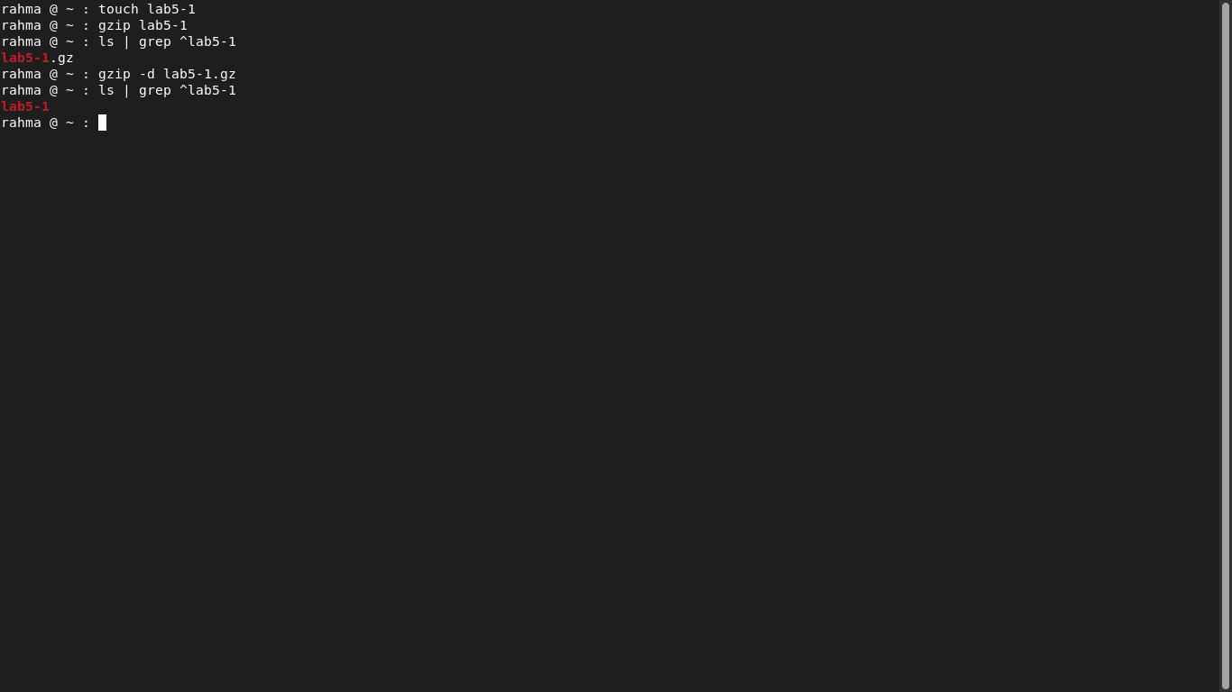

2.What is the command used to view the content of a compressed file.

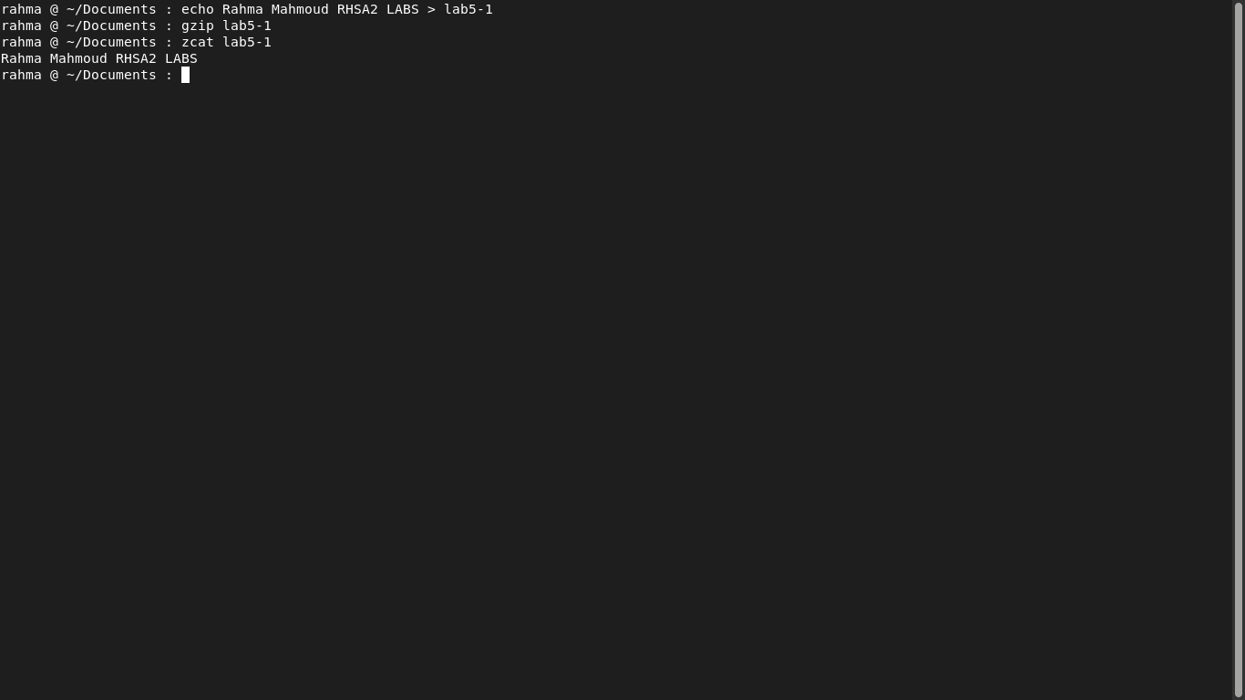

3.Backup /etc directory using tar utility.

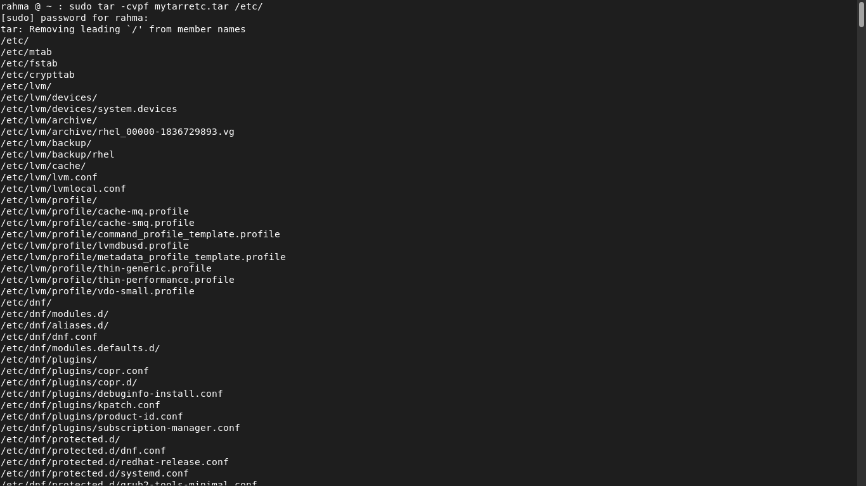

4.starting from your home directory, find all files that were

modified in the last two days.

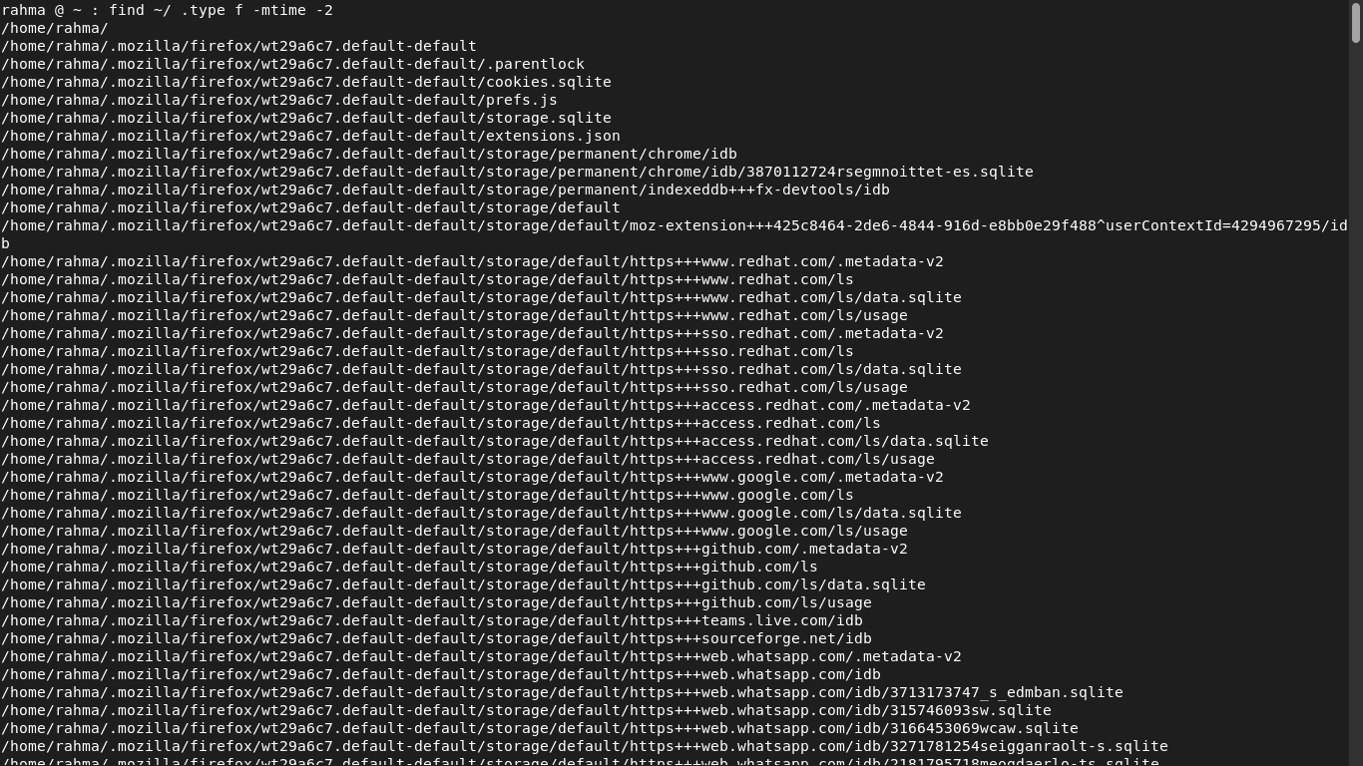

5.Starting from /etc, find files owned by root user.

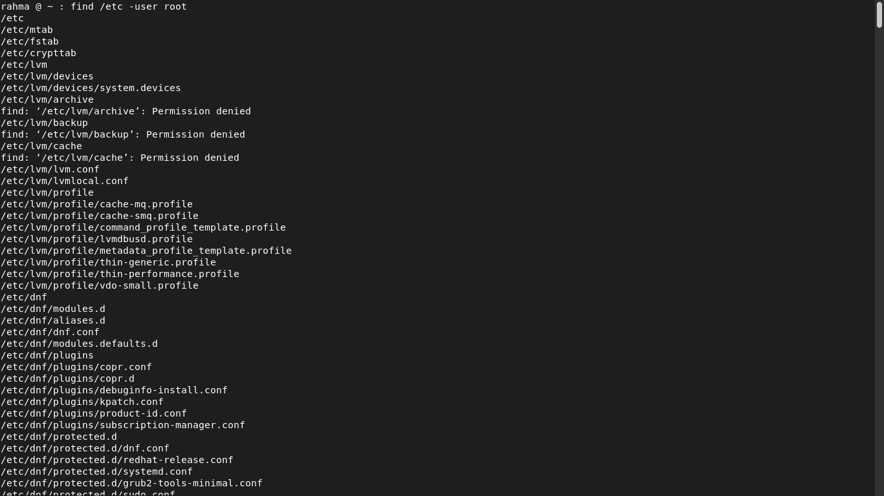

6.Find all directories in your home directory.

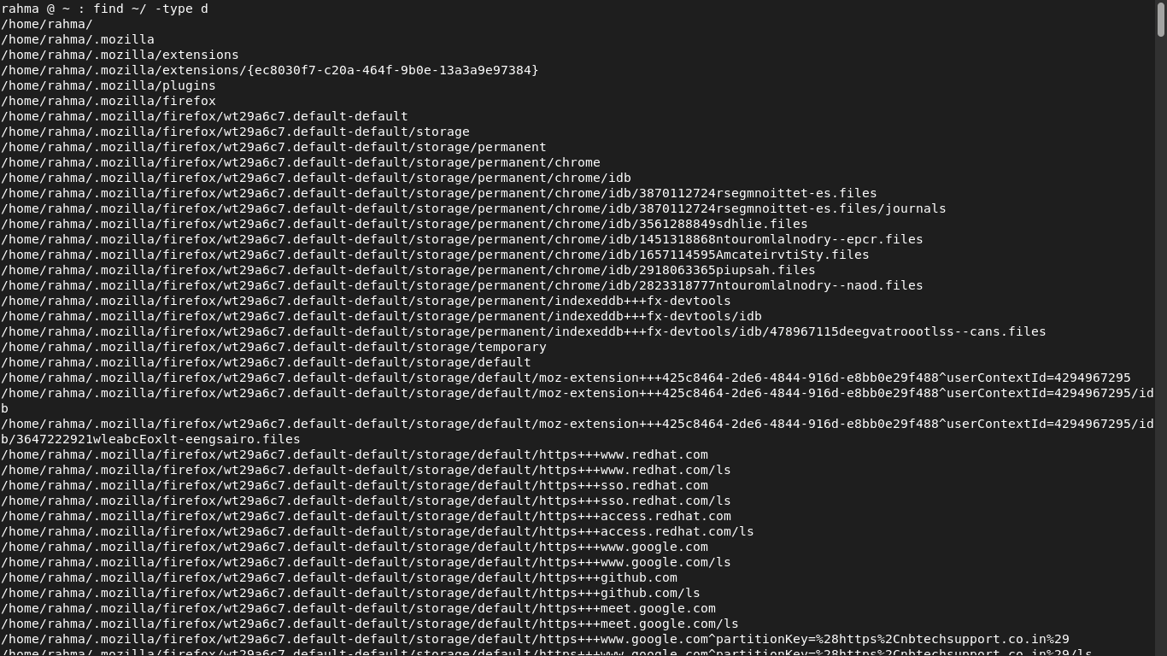

7.Write a command to search for all files on the system that, its name is “.profile”.

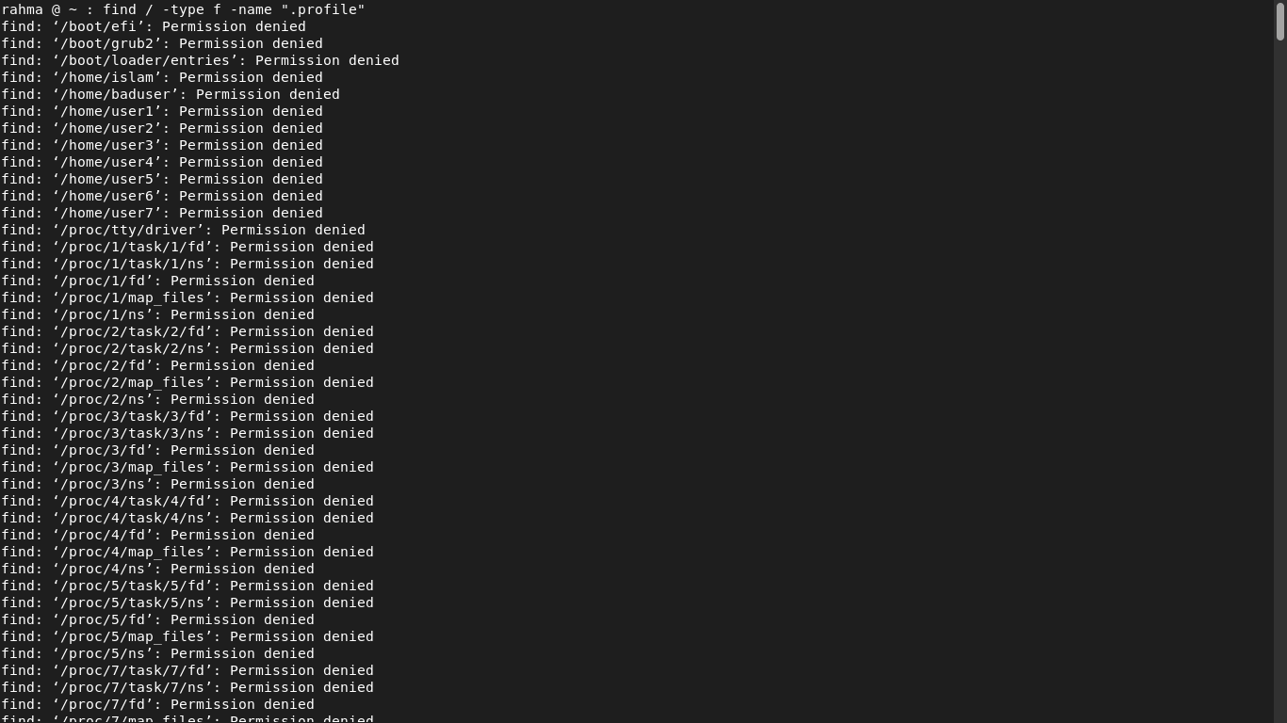

8.Identify the file types of the following: /etc/passwd, /dev/pts/0, /etc, /dev/sda/etc

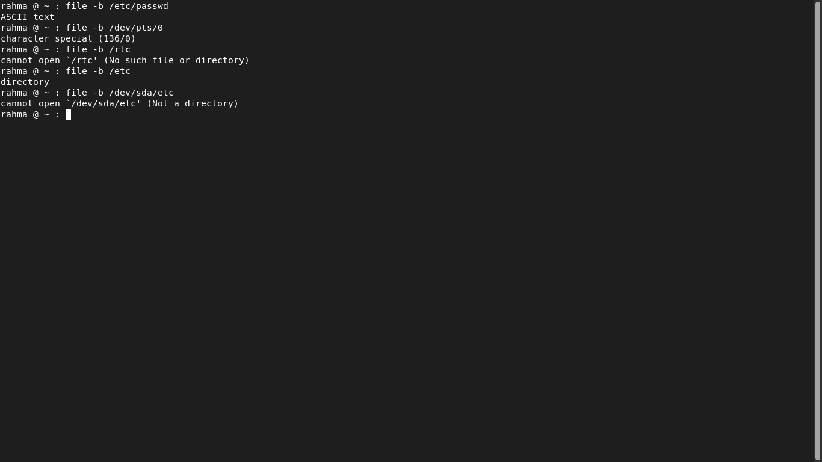

9.List the inode numbers of /, /etc, /etc/hosts.

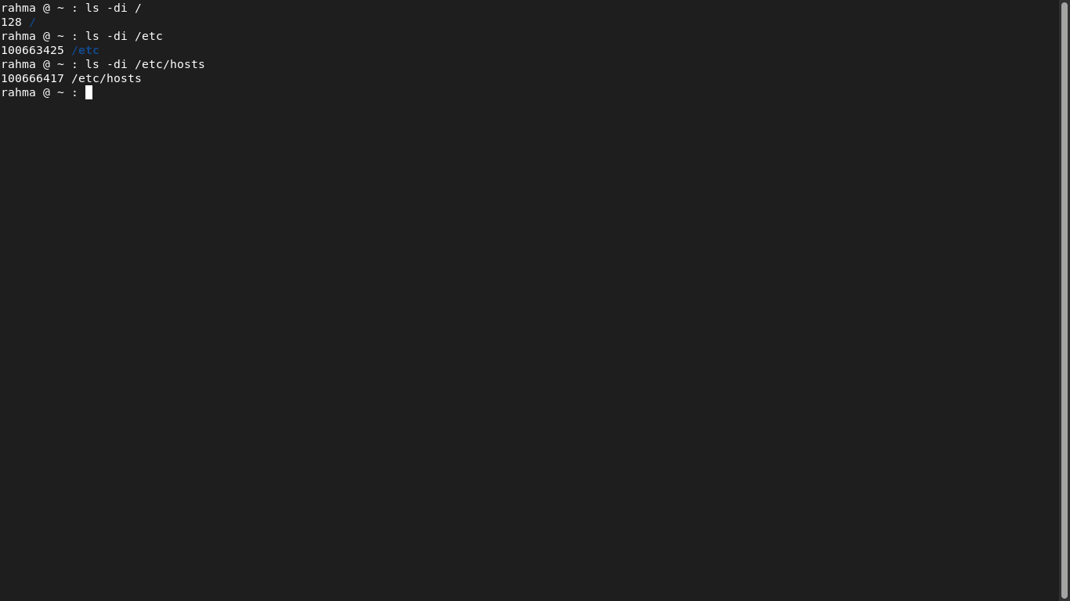

10.Copy /etc/passwd to your home directory, use the commands diff and cmp, and Edit in the file you copied, and then use these commands again, and check the output.

